ROV Inspection Report – Summer 2021
17-18 August 2021
Inspectors:
Todd Manny
Jeanette Wendler
Becca Cates

PH1CC:
The Powerhouse 1 collection channel (PH1CC) from FG 2-22 to FG 2-2 was inspected on 18 August. Considerable concrete spalling was discovered littered along the north end floor of the collection channel (Figures 1 & 2). The dive team reported there was a significant increase in size and quantity of concrete masses in comparison to observations from the previous inspection. There was bent grating found around the shaft hole of diffuser FG 2-21 (Figure 3). Almost all grating for currently closed diffusers were completely clogged (Figure 4). Many of the currently open diffusers (FG 2-22B, 22A, 21, 20, 19, 12, 8, 4) in the PH1CC were observed with partially clogged grating, allowing partial flow through grating. The first sign of measurable sediment buildup working north to south in the PH1CC was found along the south side of FG 2-18 with about 6 inches of sediment buildup at that location. Increased buildup of sediment, shells, and course woody debris was observed as the ROV inspected south through the collection channel with the greatest abundance found in the south end of the collection channel (Figures 5 & 6).
B-Branch Entrance Bay:
The B-Branch entrance bay was inspected on 18 August. Slight gaps were found around several sections of diffuser grating suggesting the grating has shifted in its slot overtime with water flow (Figures 7 & 8).
Cascades Island Entrance Bay:
The Cascades Island entrance bay was surveyed on 17 August. Everything looked as expected and no issues were found.
PH2CC:
The Powerhouse 2 collection channel (PH2CC) was inspected on 17 August. The entire inspection looked good with very minor sediment buildup and no significant findings to report.

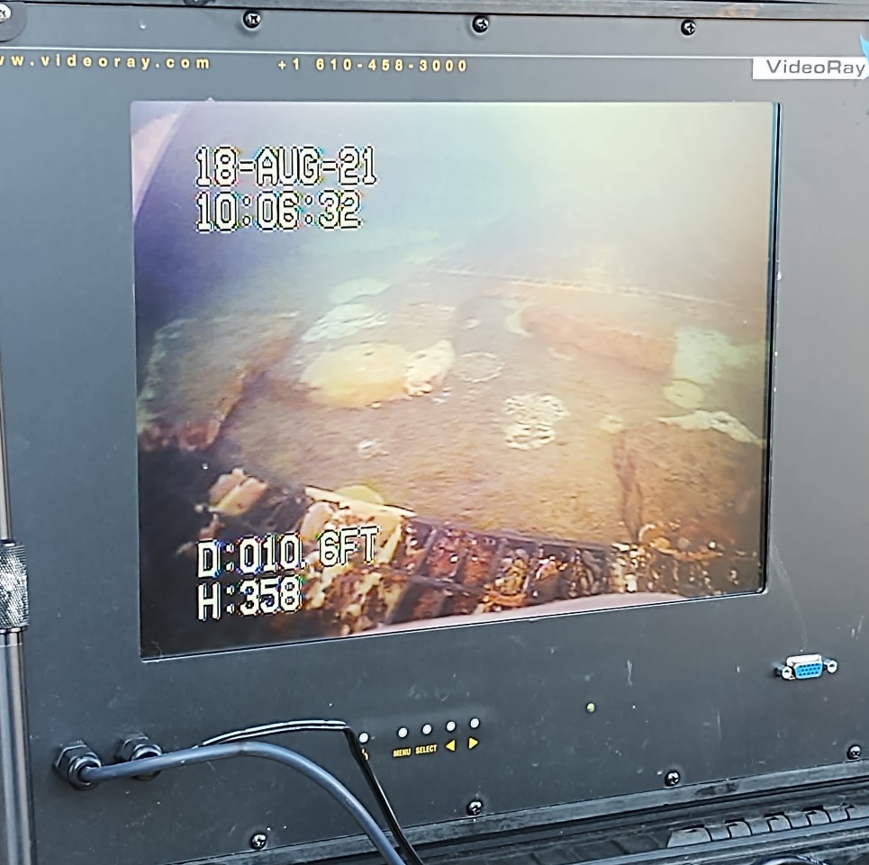
Figure 1. Rock spalling observed littered along floor of the north end of PH1CC.
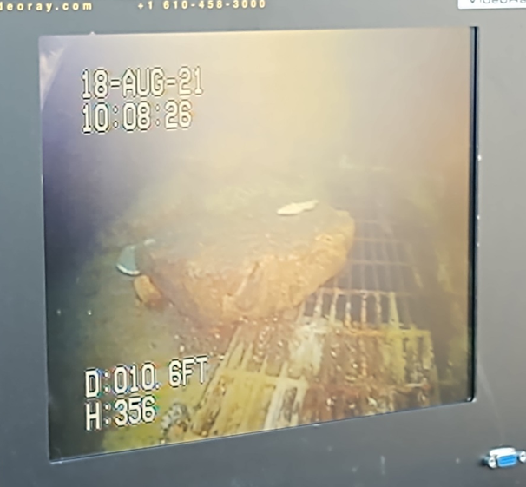
Figure 2. One of the large chucks of spalling observed littered along the floor of the north end of PH1CC.

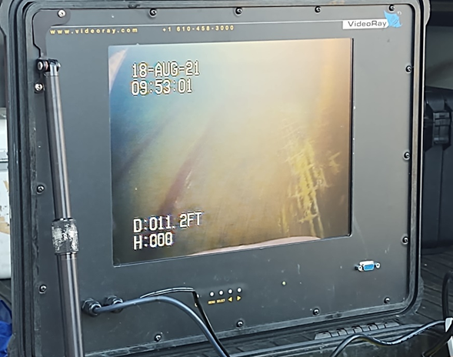
Figure 3. Bent grating around the shaft of FG 2-21.
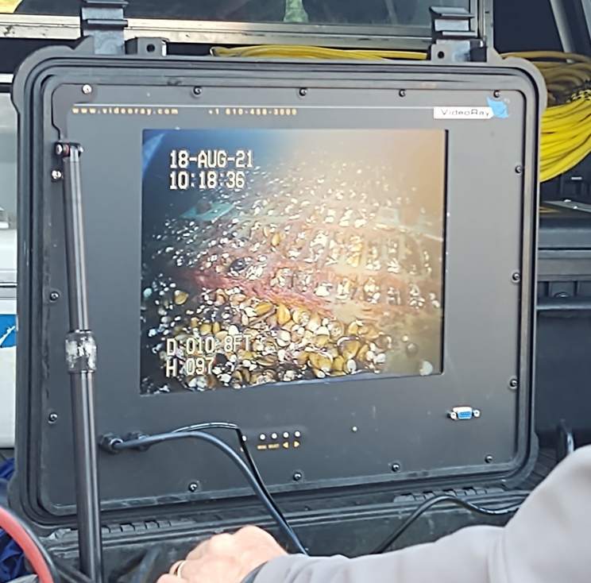
Figure 4. Completely clogged grating of a currently closed diffuser in the PH1CC.
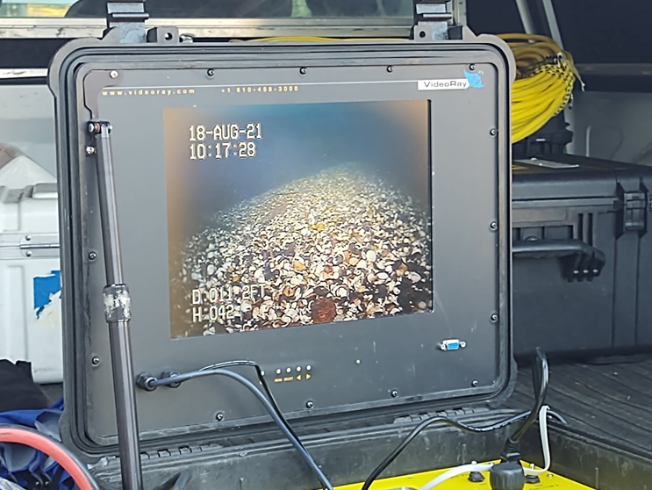
Figure 5. Example of sediment and shell buildup observed in the PH1CC.
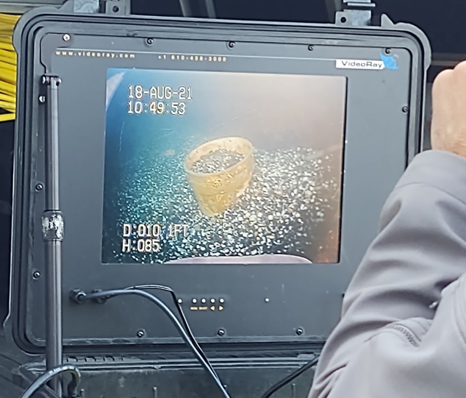
Figure 6. Example of heavy sediment and shell buildup in the southern end of the PH1CC.

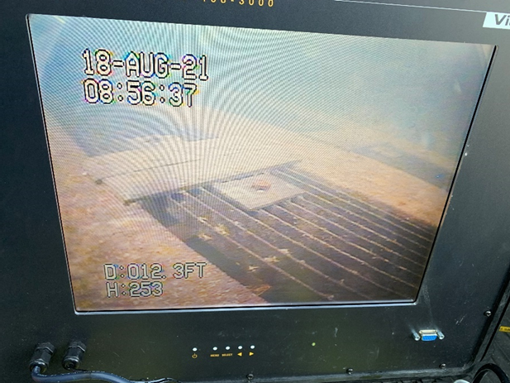
Figure 7. Example of gaps observed around edge of gratings in the B-Branch entrance bay.
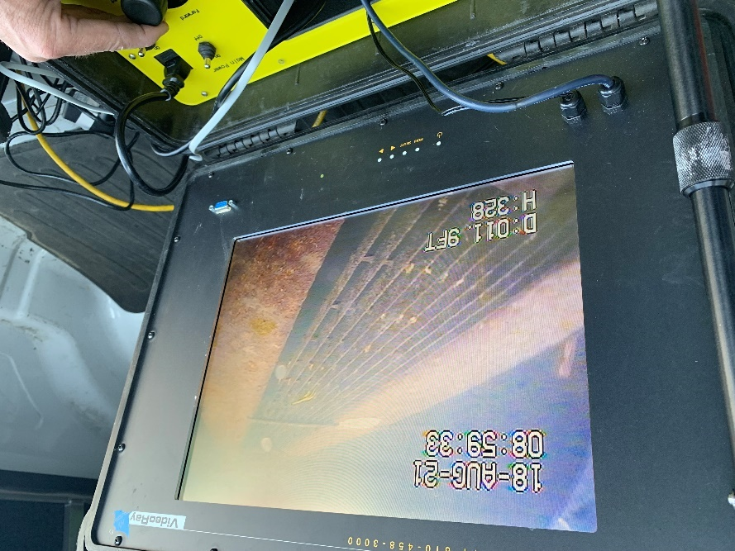
Figure 8. Example of gaps observed around the edge of gratings in the B-Branch entrance bay.

